Food Management System

Use-Case-Realization Specification: Login

Version <1.0>

Revision History

|  |  |  |  |
| --- | --- | --- | --- |
| **Date** | **Version** | **Description** | **Author** |
| <24/12/2020> | <1.1> | Final Draft | Nguyen Thi Ngoc Anh |

Table of Contents

1. Introduction 2

1.1 Purpose 2

1.2 Scope 2

1.3 Definitions, Acronyms, and Abbreviations 2

1.4 References 2

1.5 Overview 2

2. Flow of Events—Design 2

3. Derived Requirements 2

Use-Case-Realization Specification: Login

# Introduction

## Purpose

This document describes how the Login Use-Case is realized within the design model, in terms of collaborating objects.

## Scope

This document applies to the Food Management System which will be developed by TAT Restaurant.

## Definitions, Acronyms, and Abbreviations

User – a person who use the system, can be customer.

## References

None.

## Overview

In the following section, Use-Case Realization Specification of the Login Use-Case of the Food Management System is provided in detail. The first section is a textual description of the Use-Case specification. The following section contains diagrams (sequence and collaboration diagrams) describing how the use case is realized in terms of collaborating objects. The third section includes class diagrams with relationships that participate in the realization of the use case. The last section is an analysis of all requirements, such as non-functional requirements, on the use-case realization that are not considered in the design model, but that need to be taken care of during implementation.

# Flow of Events—Design

|  |  |
| --- | --- |
| **Name** | Login |
| **Actor(s)** | User |
| **Brief Description** | A user logging in to the system |
| **Triggers** | User clicks on “login” button |
| **Pre-conditions** | User already has an account |
| **Post-conditions** | System return login form and login successfully |
| **Main Event Flow** | 1. Customer access to the application 2. The system returns the login form 3. Customer enters name and password and login 4. The system validates and returns the result. |
| **Exception Flow** | * 1. Customer did not enter name and password   The system notifies users to re-enter   * 1. Customer enters wrong name and password   The system notifies users to re-enter |

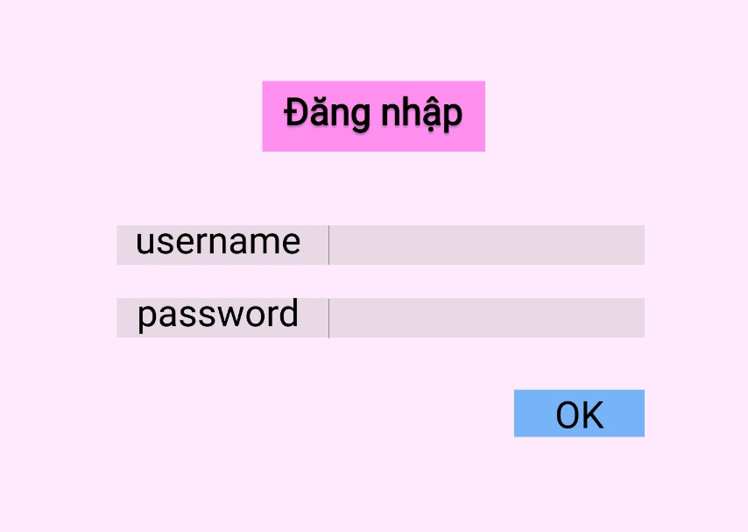

Sequence Diagram:

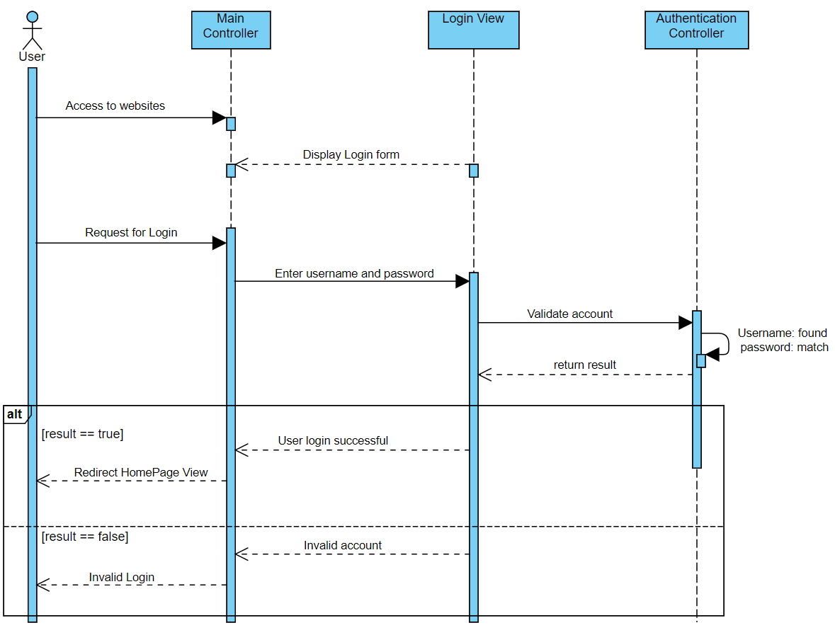

Class Diagram:

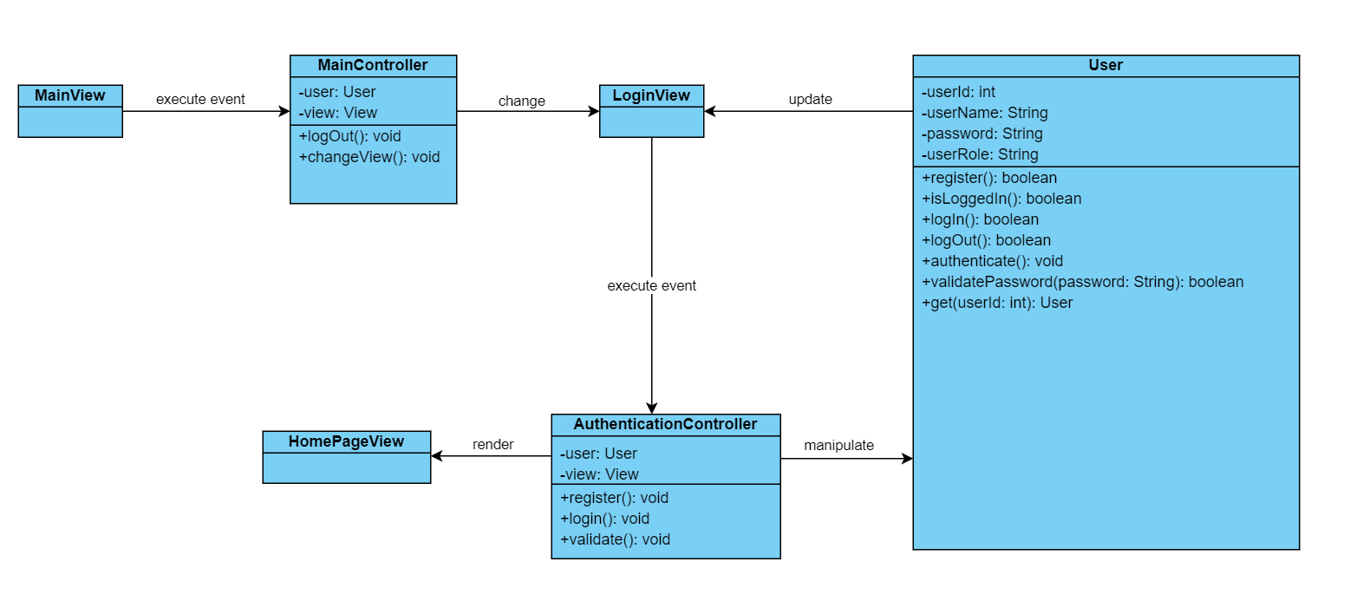

# Derived Requirements

None.